PAGE 1 — RHEL / EC2 TERMINAL — Verify System
What I did: I checked the RHEL EC2 server and reviewed the current system and storage output.
Explanation: The terminal output confirms the server state before continuing with the Auto Scaling configuration.
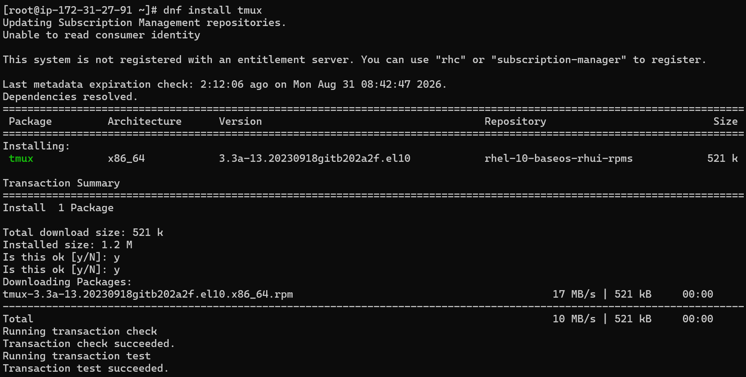

PAGE 2 — RHEL / EC2 TERMINAL — Review Output
What I did: I reviewed the command output to confirm the current EC2/RHEL configuration.
Explanation: This verification provides the baseline information for the next configuration step.
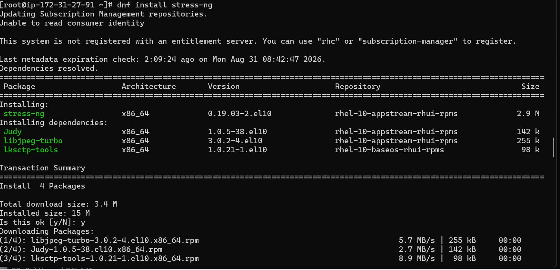

PAGE 3 — RHEL / EC2 TERMINAL — Return to Shell
What I did: I returned to the terminal after completing the previous command.
Explanation: The server is ready for the next administrative or testing action.
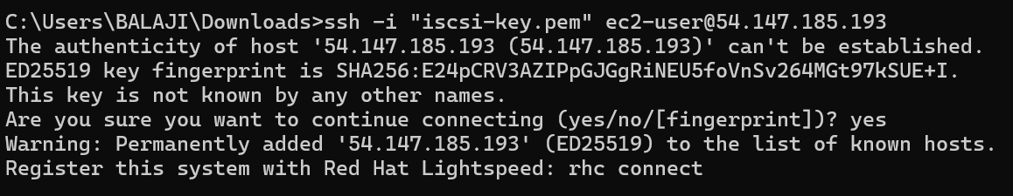

PAGE 4 — WINDOWS POWERSHELL — Test SSH Connectivity
What I did: I tested TCP connectivity to port 22 of the EC2 public address from PowerShell.
Explanation: The test checks whether SSH access to the EC2 instance is reachable.
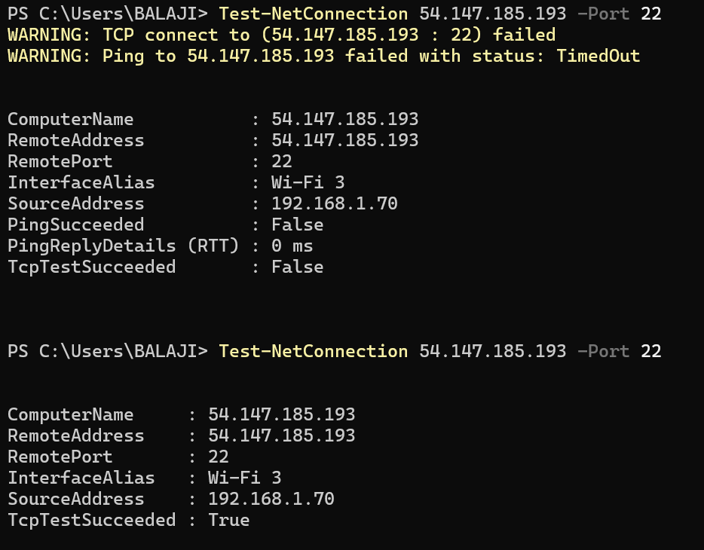

PAGE 5 — AUTO SCALING — Additional Settings
What I did: I reviewed the additional settings available in the Auto Scaling wizard.
Explanation: These options control additional behavior of the Auto Scaling group.
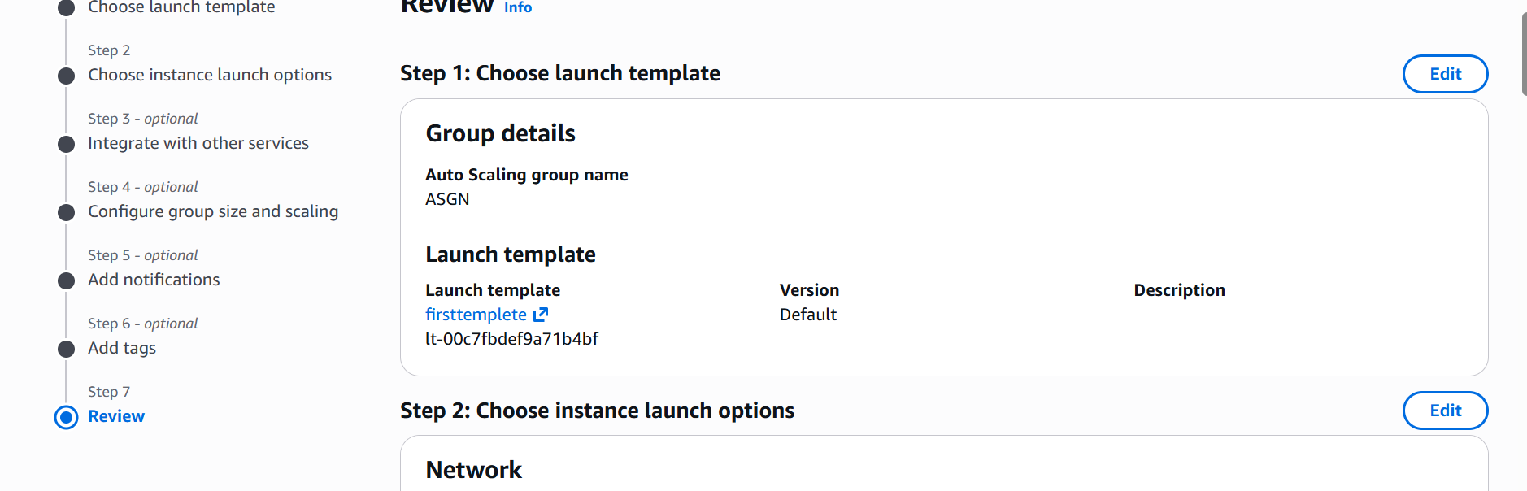

PAGE 6 — AUTO SCALING — Add Tags
What I did: I reviewed the tag settings for the Auto Scaling group.
Explanation: Tags can be used to identify and organize the Auto Scaling resources.
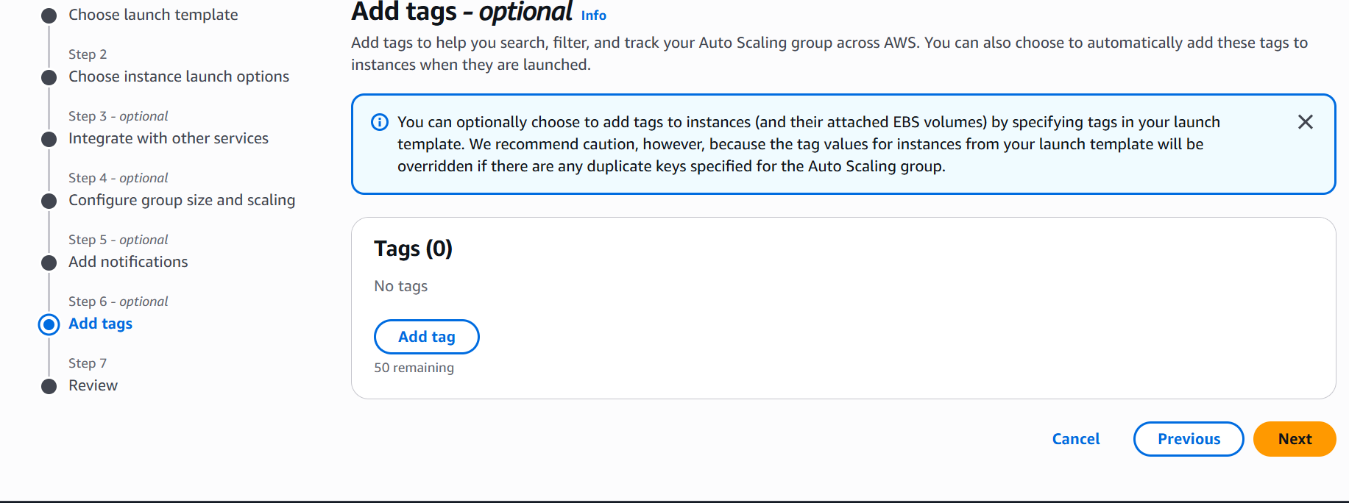

PAGE 7 — AUTO SCALING — Add Notifications
What I did: I reviewed the optional notification settings.
Explanation: This section is used to configure notifications for Auto Scaling events.
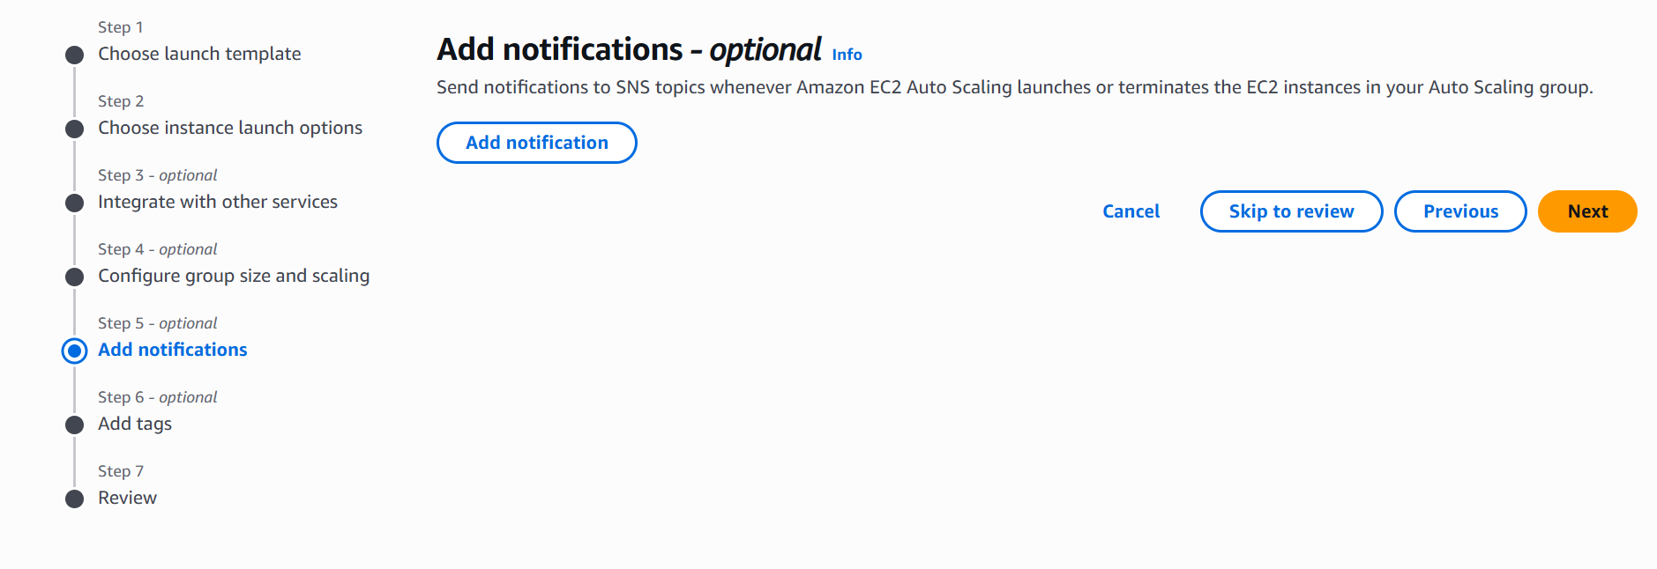

PAGE 8 — AUTO SCALING — Review Group Size
What I did: I reviewed the group-size and scaling settings before continuing.
Explanation: These values define the capacity and scaling range of the group.
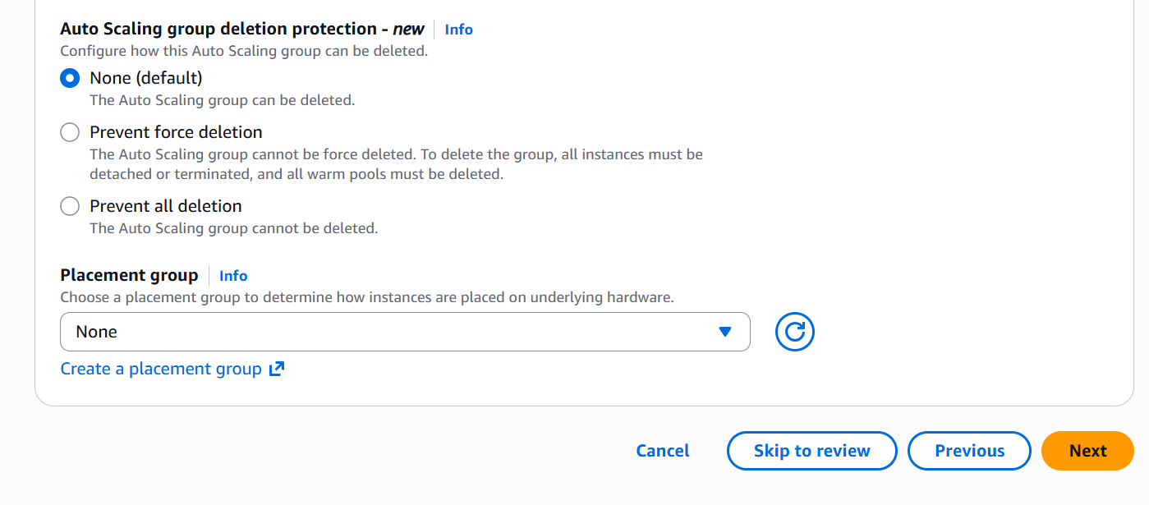

PAGE 9 — AUTO SCALING — Additional Capacity
What I did: I reviewed the additional capacity settings.
Explanation: These options control how the Auto Scaling group obtains and manages instance capacity.
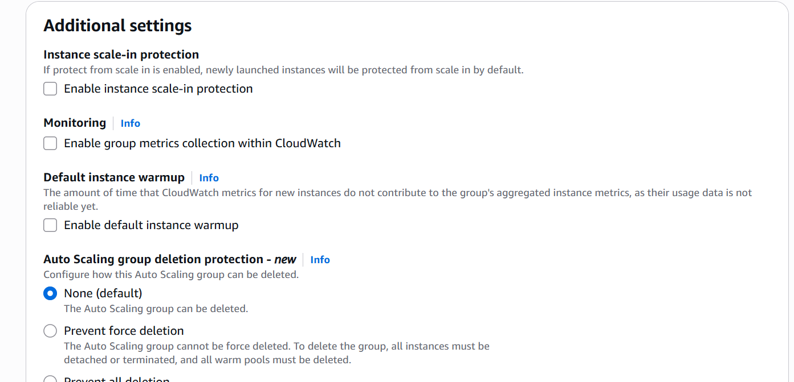

PAGE 10 — AUTO SCALING — Instance Maintenance Policy
What I did: I reviewed the instance maintenance policy options.
Explanation: The policy controls how instances are maintained or replaced during Auto Scaling operations.
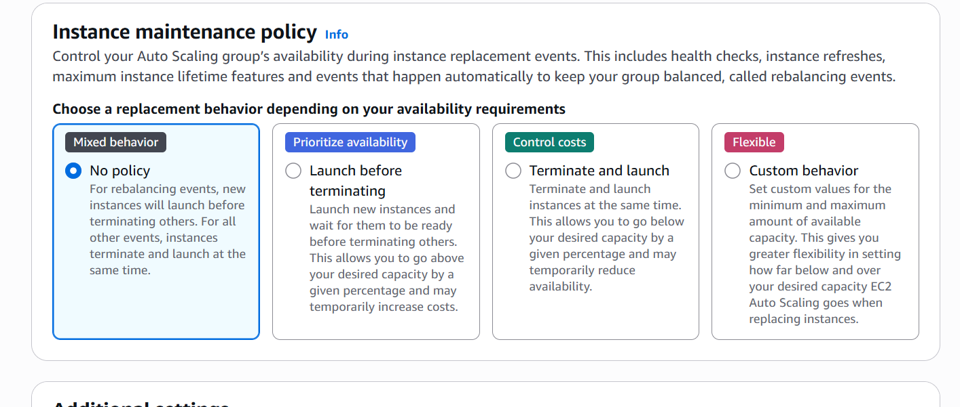

PAGE 11 — AUTO SCALING — Group Size
What I did: I reviewed the desired, minimum, and maximum capacity fields.
Explanation: These values control the number of instances maintained by the Auto Scaling group.
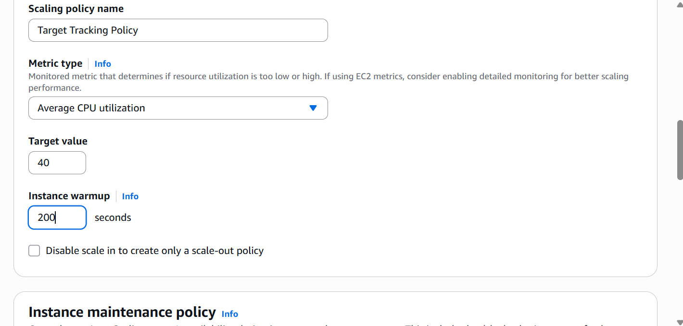

PAGE 12 — AUTO SCALING — Scaling Policy
What I did: I reviewed the scaling policy and automatic scaling options.
Explanation: The scaling policy controls when the group increases or decreases capacity.
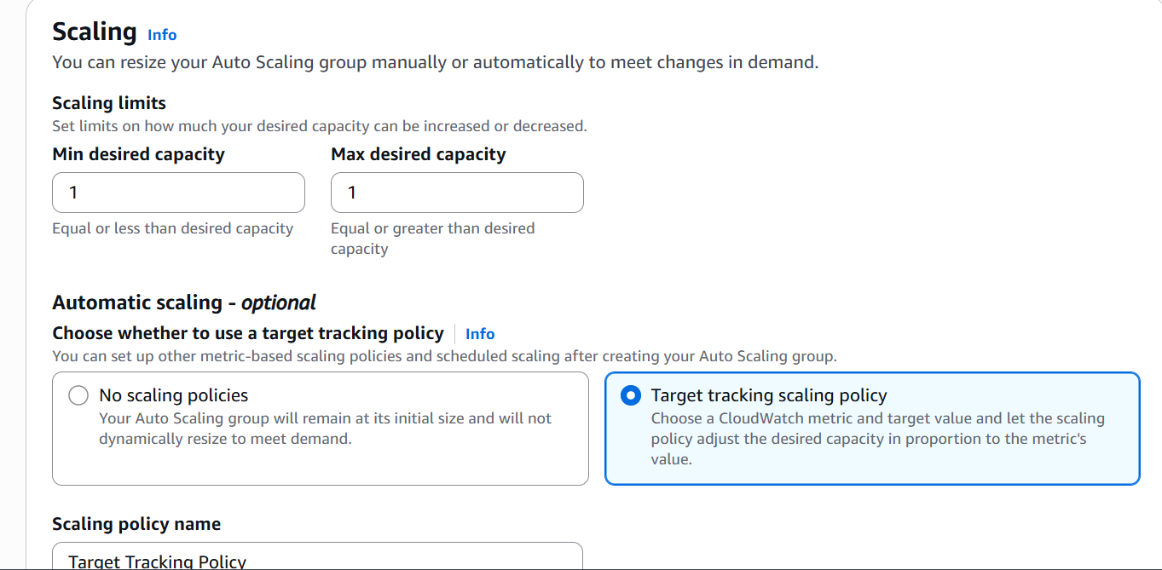

PAGE 13 — AUTO SCALING — Configure Group Size
What I did: I reviewed the final group-size configuration.
Explanation: This confirms the capacity values before completing the Auto Scaling setup.
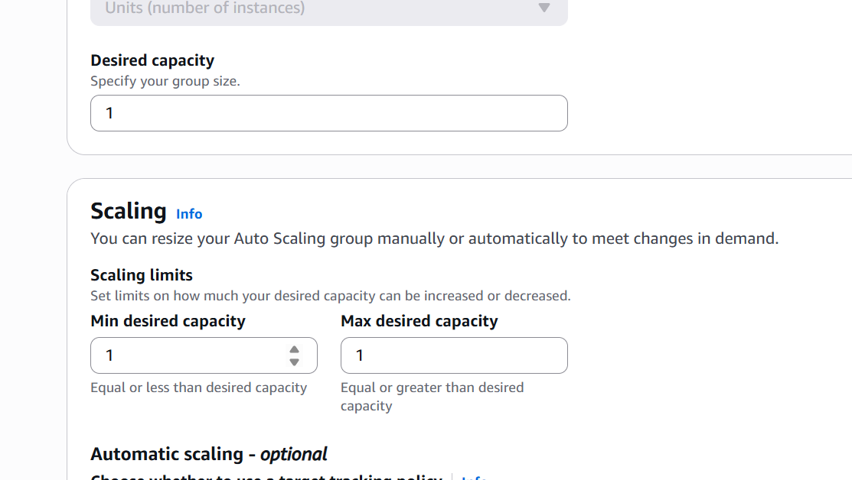

PAGE 14 — AUTO SCALING — Service Integration
What I did: I reviewed the optional integration settings with other AWS services.
Explanation: These options allow the Auto Scaling group to integrate with additional services.
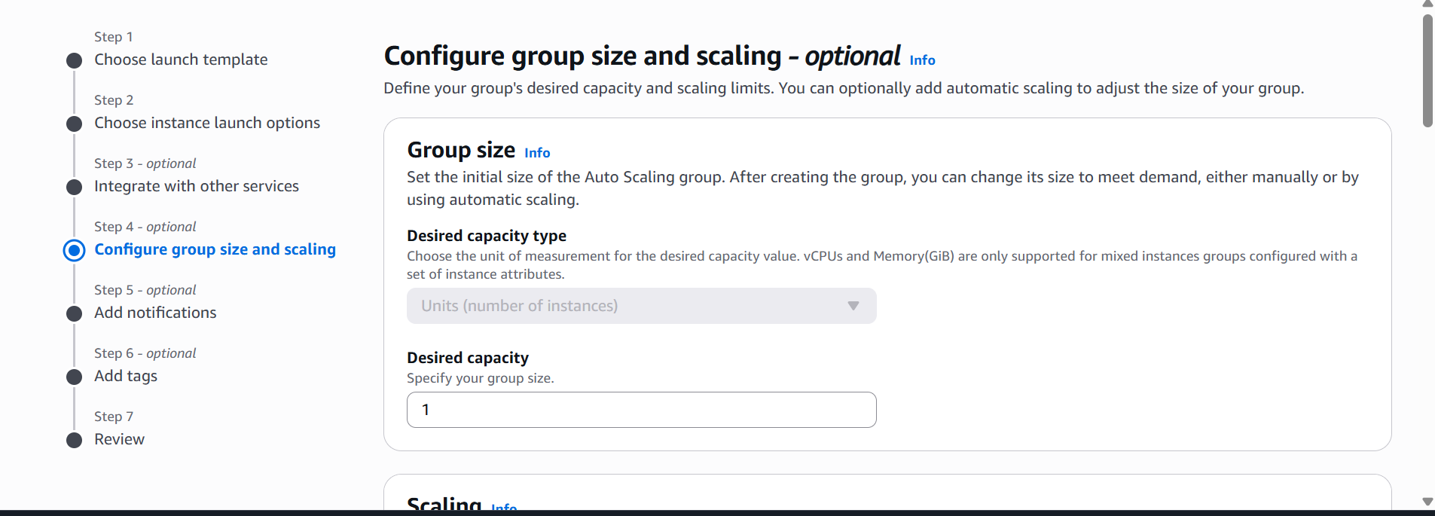

PAGE 15 — AUTO SCALING — Health Checks
What I did: I reviewed the EC2 and additional health-check settings.
Explanation: Health checks help identify unhealthy instances so they can be replaced when required.
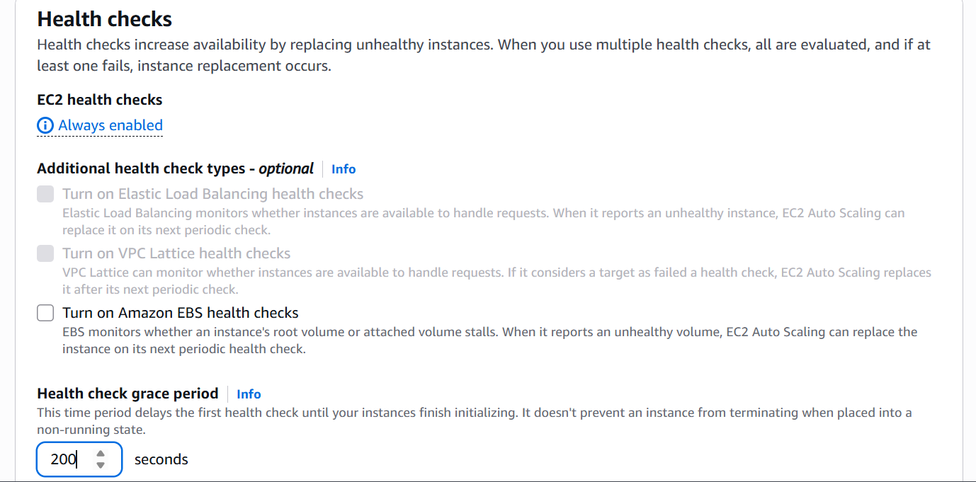

PAGE 16 — AUTO SCALING — VPC Lattice
What I did: I reviewed the VPC Lattice integration option.
Explanation: The page provides the option to attach the Auto Scaling group to a VPC Lattice service.
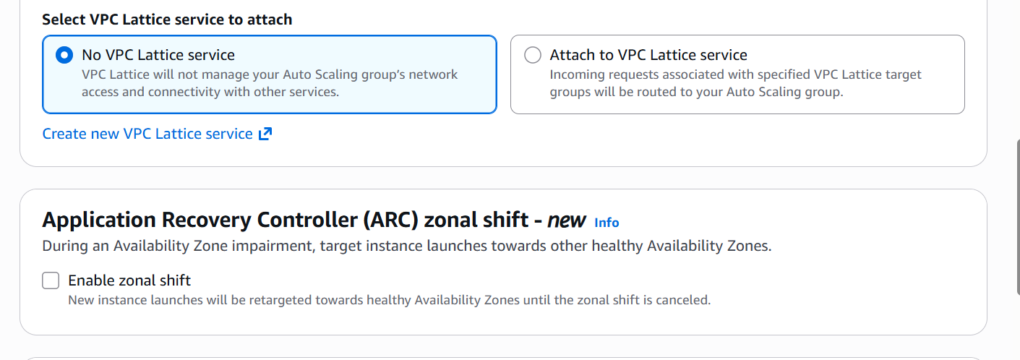

PAGE 17 — AUTO SCALING — Instance Launch Options
What I did: I reviewed the instance launch configuration.
Explanation: These settings define the common configuration used when instances are launched.
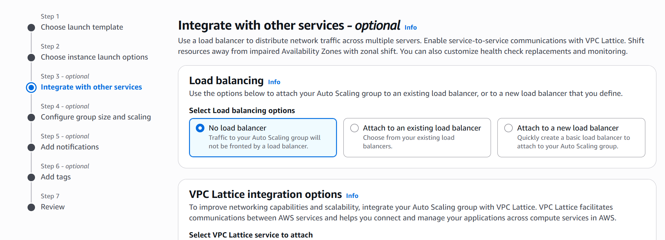

PAGE 18 — AUTO SCALING — Capacity Reservation
What I did: I reviewed the capacity-reservation preference.
Explanation: This setting controls how launched instances use available EC2 capacity.
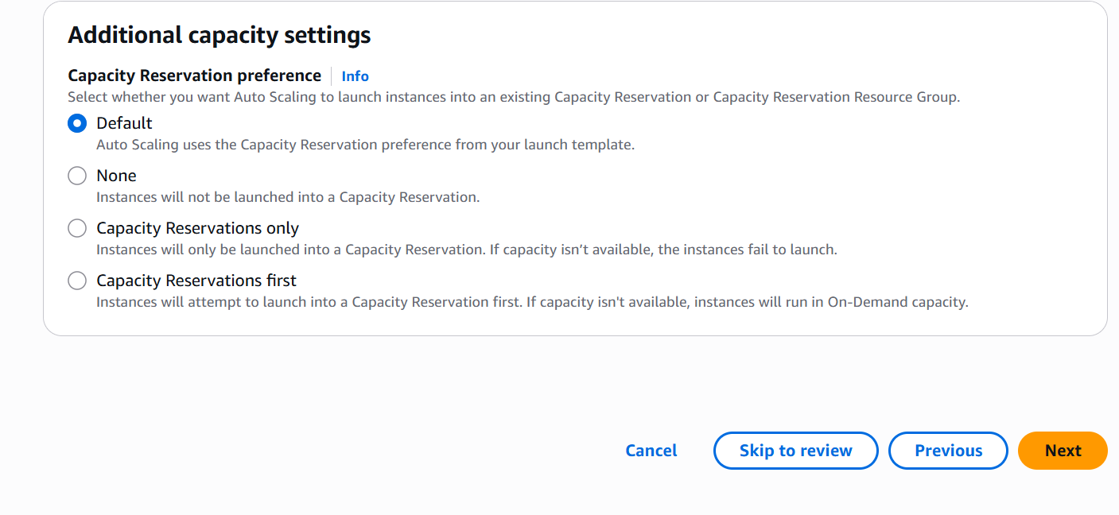

PAGE 19 — AUTO SCALING — Launch Template
What I did: I selected/reviewed the launch template for the Auto Scaling group.
Explanation: The launch template supplies the EC2 configuration used to launch instances.
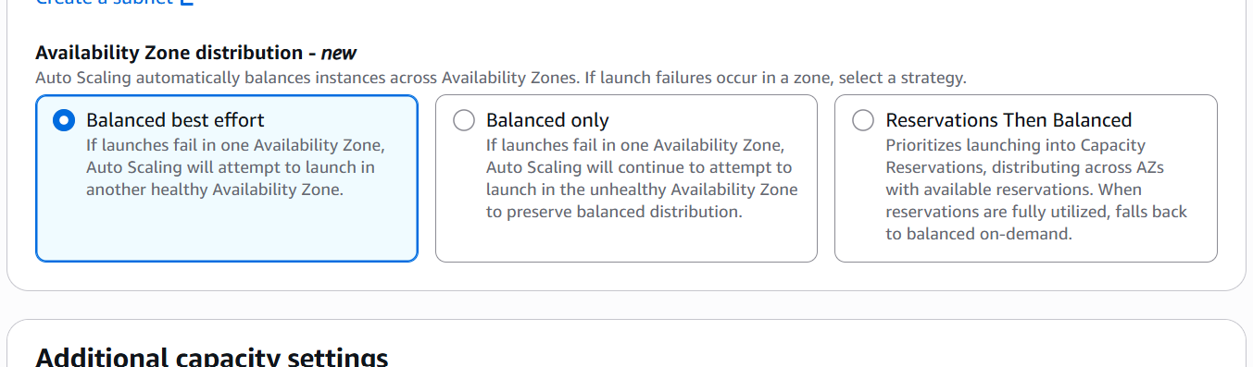

PAGE 20 — AUTO SCALING — Next Step
What I did: I clicked Next to continue through the Auto Scaling wizard.
Explanation: The wizard moves to the next configuration stage.
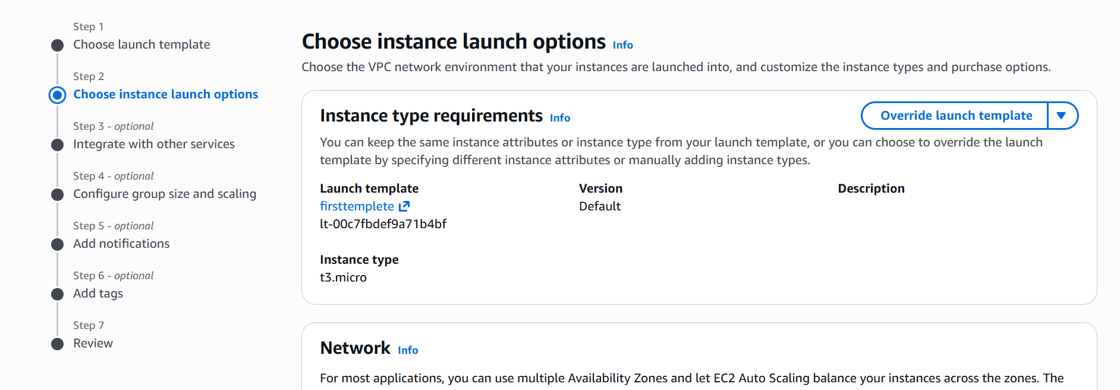

PAGE 21 — AUTO SCALING — Create Group
What I did: I selected Create Auto Scaling group.
Explanation: This starts the Auto Scaling group creation process.


PAGE 22 — EC2 — Auto Scaling Groups
What I did: I opened Auto Scaling Groups from the EC2 console.
Explanation: This section is used to create and manage Auto Scaling groups.
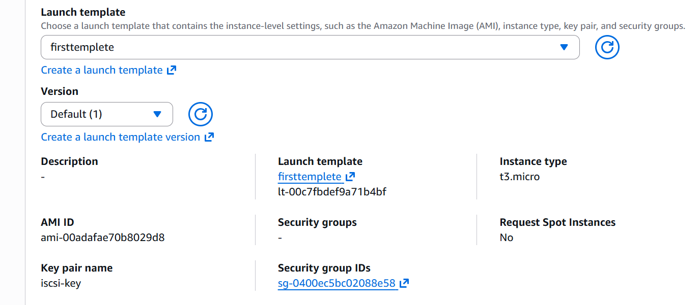

PAGE 23 — AUTO SCALING — Security Group
What I did: I selected the required security group.
Explanation: The security group controls network access for the instances.
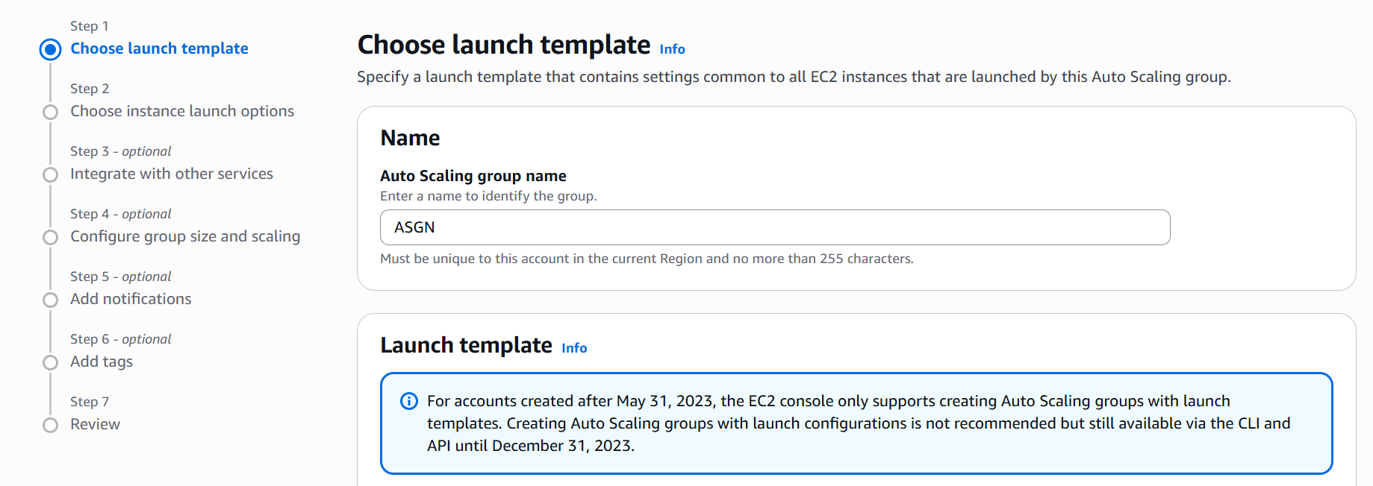

PAGE 24 — AUTO SCALING — Confirm Security Group
What I did: I confirmed the selected security group.
Explanation: The selected group will be associated with the launched instances.


PAGE 25 — AUTO SCALING — Availability Zone
What I did: I selected/reviewed the Availability Zone configuration.
Explanation: The Availability Zone determines where the instances can be placed.


PAGE 26 — AUTO SCALING — Network Settings
What I did: I selected the required subnet/network setting.
Explanation: The subnet determines the VPC network location of the instances.
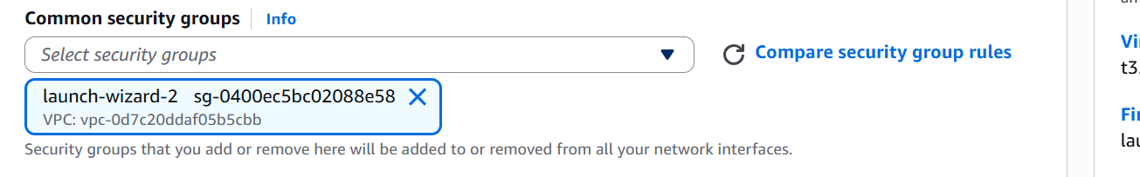

PAGE 27 — AUTO SCALING — Key Pair
What I did: I selected the required EC2 key pair.
Explanation: The key pair provides secure login access to the EC2 instances.
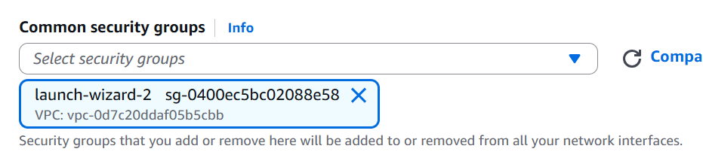

PAGE 28 — AUTO SCALING — Instance Type
What I did: I selected the required EC2 instance type.
Explanation: The instance type defines the compute resources assigned to the instances.
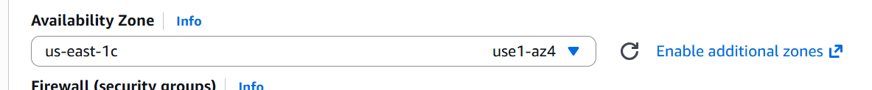

PAGE 29 — LAUNCH TEMPLATE — Name and Description
What I did: I entered the launch template name and description.
Explanation: The name identifies the reusable launch configuration.
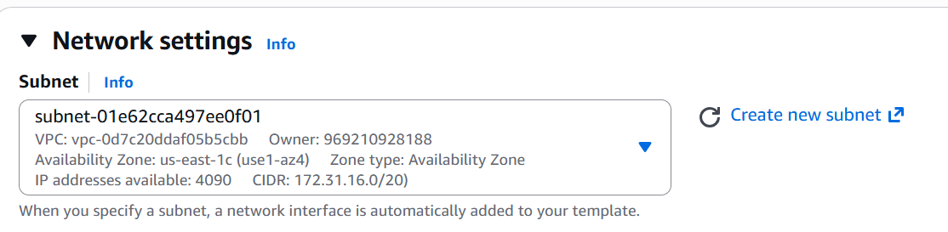

PAGE 30 — LAUNCH TEMPLATE — Create
What I did: I selected Create launch template.
Explanation: This creates the reusable EC2 launch configuration.
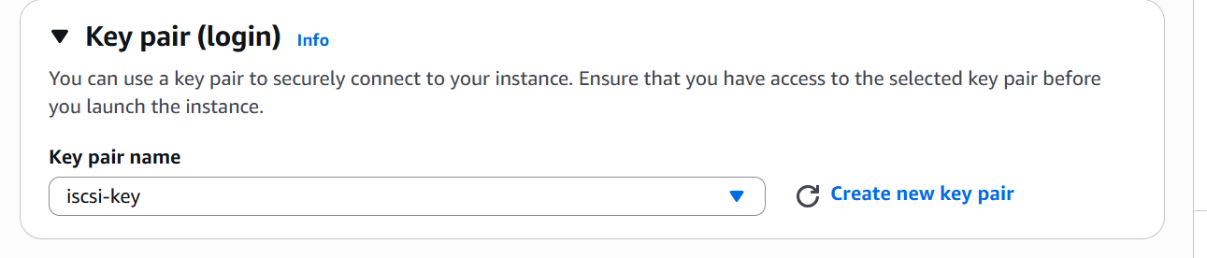

PAGE 31 — EC2 — Launch Templates
What I did: I opened the Launch Templates section.
Explanation: Launch Templates store the common EC2 settings used when launching instances.
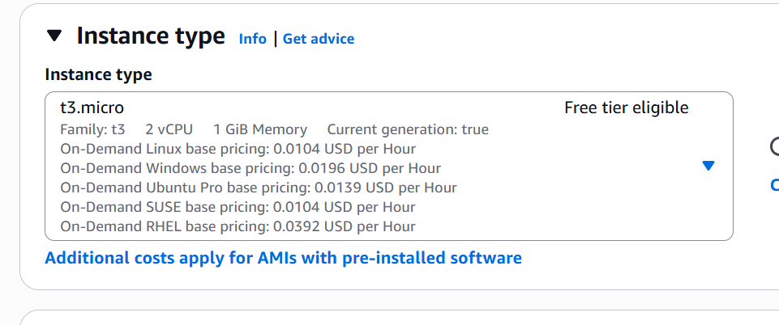

PAGE 32 — EC2 — Launch Template
What I did: I opened the launch-template configuration from the EC2 service.
Explanation: This is where the instance launch configuration is created and managed.
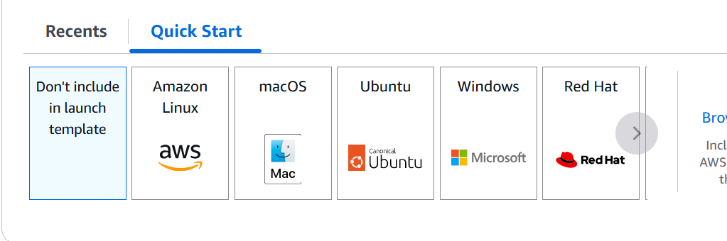

PAGE 33 — LAUNCH TEMPLATE — Configuration
What I did: I reviewed the launch-template configuration and selected settings.
Explanation: The configuration contains the EC2 details that will be reused by the Auto Scaling group.
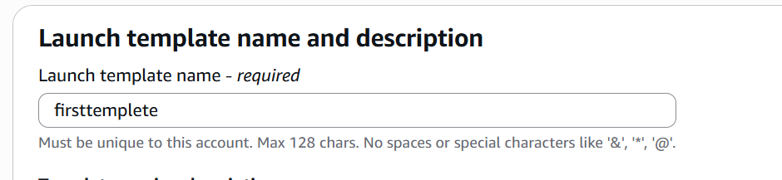

PAGE 34 — EC2 — Launch Template Review
What I did: I reviewed the launch-template page and its available settings.
Explanation: This confirms the launch configuration before it is used by the Auto Scaling group.


PAGE 35 — EC2 — Launch Templates Overview
What I did: I reviewed the Launch Templates area in the EC2 console.
Explanation: The console is ready for creating or managing the launch template.


PAGE 36 — EC2 — Final Launch Template Screen
What I did: I reviewed the final Launch Template screen and the available EC2 configuration.
Explanation: This is the final screenshot in the original document order and is kept in the same position.


